UNIVERSITY OF GHANA DENTAL SCHOOL
Korle Bu Campus · Accra, Ghana
UGDS Hospital Management System
Project Documentation & Strategic Roadmap
Document Reference: UGDS-HMS-DOC-2026-01
Document Version: 2.0
Date: September 2026
Prepared by: Customer Care & Digital Systems Unit
Classification: Internal — Institutional Leadership & Governance
Phase 1: Deployed & Operationally Verified | Phases 2–3: Planned

1. Executive Summary & Strategic Vision
The UGDS Hospital Management System (UGDS-HMS) is a multi-phase digital transformation programme for the University of Ghana Dental School. It is designed to take the institution from a paper-and-folder patient record system to a fully integrated hospital management and electronic medical record (EMR) platform, delivered in three deliberately sequenced phases so that each stage produces standalone institutional value while laying the technical foundation for the next.
Phase 1 — the Patient Feedback Survey Management System — is complete and operationally verified. It connects UGDS's physical archive of 125,042 patient records to an automated SMS survey pipeline, a real-time governance dashboard, and monthly executive reporting for the Dean's office. This phase proved the core technical pattern the rest of the programme builds on: legacy records feeding a cloud-hosted database, surfaced through role-based web portals.
Phase 2 will extend this foundation with intelligent record tracking and workflow routing — moving the institution from passive feedback collection to active operational coordination between front desk, clinical units, and administration.
Phase 3 is the long-term vision: a full enterprise Hospital Management System with electronic medical records, appointment scheduling, diagnostic and billing integration, and a unified patient-facing and clinical portal.
This document consolidates the delivered Phase 1 system, the Phase 2 and Phase 3 roadmap, and the architectural, security, and governance considerations that apply across all three phases. It is intended for review and sign-off by UGDS leadership ahead of Phase 2 planning.

2. System Architecture
The system is built on a consistent architectural pattern that is designed to extend across all three phases without requiring a platform rebuild. Each phase adds new services and portals on top of the same core data platform, rather than replacing what came before it.

2.1 Technology Stack
- Frontend: React 18 + Vite, Recharts for data visualisation (Phase 1); extended with role-specific portals in Phases 2 and 3
- Backend: FastAPI (Python), organised as versioned services that grow with each phase
- Database: Neon PostgreSQL — a single, cloud-hosted, versioned schema shared and extended across all phases
- Messaging: Arkesel SMS Gateway (API v2) for survey dispatch, birthday outreach, and — from Phase 2 — operational alerts
- On-premises integration: a custom Windows folder-watcher service (UGDS_SMS) bridging the legacy eArchive system to the cloud backend
- Hosting: on-premises local server for Phase 1, with cloud-hosted database services; Phase 2/3 hosting model to be confirmed as part of security & compliance sign-off

2.2 Architectural Principles
- Single source of truth: one PostgreSQL platform, extended with new tables and services per phase rather than duplicated databases
- Additive integration: each phase's daemon or gateway plugs into the existing backend without disrupting prior-phase services
- Role-based access at every layer: authentication and authorisation are enforced consistently as new portals are added
- Progressive exposure: internal staff-facing tools precede patient-facing tools, so clinical and administrative workflows are proven before being exposed externally in Phase 3

3. System Architecture Diagram
The diagram below shows how the on-premises daemon layer, cloud backend, shared database, external integrations, and frontend portals relate to one another, and how each phase extends the same underlying platform rather than replacing it.
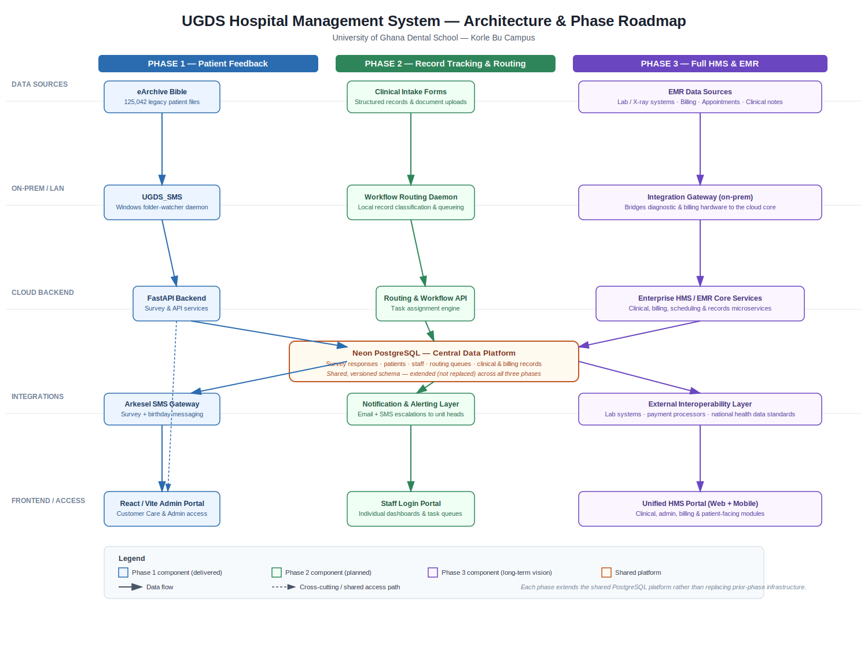
Figure 1. UGDS-HMS architecture and phase roadmap, showing shared use of the central PostgreSQL data platform across all three phases.

4. Phase 1 — Patient Feedback Survey Management System
Status: Complete and operationally verified.
Phase 1 is a real-time clinical governance and patient engagement platform. It bridges UGDS's physical archive of 125,042 patient records with automated digital touchpoints, transforming how the institution captures, monitors, and acts on patient experience data.

4.1 The Problem This Phase Solved
Challenge | Institutional Impact
No structured way to collect patient feedback | Clinical quality blind spots
Patient records locked in physical folders | Patients could not be reached for follow-up
No visibility into underperforming clinics | Leadership lacked a data-driven governance tool
Birthday outreach was manual or non-existent | Missed relationship-building opportunities
No monthly performance reports for the Dean's office | Decisions were based on opinion, not evidence

4.2 Delivered Modules

Secure Login Portal
- Staff name search + PIN authentication, with username/password fallback
- Role-based access control (Admin, Customer Care Officer, Unit Head)
- Restricted to authorised UGDS personnel only, with UGDS institutional branding

Overview Dashboard
- Live satisfaction rate, total responses, and recommendation rate
- Follow-up request tracking for flagged patients requiring a callback
- Quality-of-care metrics chart across clinical care dimensions
- Recent comments feed and an active-complaints panel for red-flagged issues
- Clinic performance table and follow-up requests broken down by unit, with a unit filter

Analytics Module
- Per-clinic satisfaction comparison and per-question quality-of-care breakdown
- Environment scores (cleanliness, waiting-area comfort)
- Affordability scores (cost transparency, payment satisfaction)

Monthly Executive Report
- Institutional letterhead formatted for the Dean's office and clinical leadership
- Auto-dated summary KPIs: satisfaction rate, recommendation rate, total surveys, follow-up calls
- Unit and clinic quality breakdown table, with CSV export and print/save-as-PDF
- Month selector for historical comparison

Birthday Outreach Hub
- Today's, tomorrow's, this-week, and this-month celebrant lists
- "Call personally" workflow so customer care officers add a human touch alongside automated SMS
- Call completion logging via a checkmark action

Patients Directory
- Searchable index connected to all 125,042 archived patient records
- Search by name, patient ID, or phone number; visit status and last-visit date on each profile
- Forms the data foundation Phase 3 builds its full patient management module on

Unit Quality Flags & Staff Performance
- Automated red-flag alerts when a unit's satisfaction score falls below threshold, with email notification to unit heads
- Per-staff satisfaction scores, follow-up attribution, and complaint linkage
- Weekly/monthly unit leaderboard visible to all staff

Patient Outreach SMS Engine
- UGDS_SMS folder-watcher service monitors the legacy eArchive output for new patient records
- New records automatically trigger a survey SMS via the Arkesel API
- Anonymous, multi-question survey on a 1–5 scale; responses parsed and stored in PostgreSQL with zero manual staff effort

4.3 Phase 1 Delivery Summary
Module | Status
Secure Login Portal | Complete
Overview Dashboard | Complete
Patient Feedback Collection (SMS) | Complete
Follow-up Requests Module | Complete
Analytics Module | Complete
Unit Leaderboard | Complete
Unit Quality Flags + Email Alerts | Complete
Staff Performance Tracking | Complete
Monthly Executive Report (PDF/CSV) | Complete
Birthday Outreach Hub | Complete
Patients Directory (125k records) | Complete
Export Data | Complete

5. Phase 2 — Intelligent Record Tracking & Workflow Routing
Status: Planned — to be scoped following Phase 1 sign-off.
Phase 2 shifts the platform from passive feedback collection to active operational coordination. Where Phase 1 tells leadership how patients feel after the fact, Phase 2 is designed to track a patient record and a staff task in real time as they move through the institution — from front-desk intake, to the correct clinical unit, to resolution — with visibility for staff and escalation for administrators when something stalls.

5.1 Why This Phase Matters
- Phase 1's Patients Directory and quality-flag alerts surface problems after the fact; Phase 2 is designed to route and track work as it happens, closing that gap
- Individual staff currently have no personal dashboard of their own outstanding tasks or performance — Phase 2 introduces one
- Unit-level quality alerts today only reach unit heads by ad hoc email; Phase 2 formalises this into a structured, auditable notification and alerting layer

5.2 Planned Modules

Workflow Routing Engine
- A local record-classification daemon that reads incoming intake and clinical records and routes them to the correct unit or officer
- Configurable routing rules by unit, urgency, and record type
- Task queue view so front-desk and clinical staff can see what has been assigned to them and its status

Staff Login Portal
- Individual staff dashboards showing personal performance metrics, assigned tasks, and follow-up attribution
- Extends Phase 1's PIN/username authentication to a fully personalised staff view

In-App Notification Centre
- Real-time in-portal alerts for new complaints, callbacks, and quality flags, replacing ad hoc email as the sole channel
- Notification history and read/unread status per staff member

Email Alert System
- Automated, templated email to unit heads and administrators when a quality flag is raised
- Escalation rules for flags that remain unresolved beyond a configurable window

Birthday Campaign Scheduling
- Pre-scheduled birthday and outreach campaigns with reusable message templates
- Extends Phase 1's Birthday Outreach Hub from a daily manual-call list to a schedulable campaign tool

Advanced Analytics
- Trend analysis and month-over-month comparisons across all Phase 1 quality metrics
- Predictive quality flags that surface likely underperformance before it crosses the Phase 1 threshold

Mobile-Responsive Design
- Full mobile optimisation of the admin and staff portals for tablets and phones, supporting ward- and clinic-floor use

5.3 Architectural Impact
Phase 2 introduces a Workflow Routing Daemon on-premises and a Routing & Workflow API in the cloud backend, both of which write to the same shared PostgreSQL platform used in Phase 1 — see Figure 1. No Phase 1 module is replaced; the Notification & Alerting Layer sits alongside the existing Arkesel SMS integration rather than displacing it.

6. Phase 3 — Full Enterprise Hospital Management System & EMR
Status: Long-term vision — scope, data-protection, and interoperability requirements to be defined in detail before commitment.
Phase 3 is the long-term destination of the programme: a complete digital ecosystem covering clinical, diagnostic, billing, and scheduling operations for UGDS, built on the same data platform established in Phase 1 and extended in Phase 2. Because this phase involves electronic medical records and financial data, it carries materially higher regulatory and security requirements than Phases 1 and 2 — see Section 8, Security & Compliance.

6.1 Planned Modules

Full Patient Management System
- Complete patient profiles, visit history, and treatment records, replacing the Phase 1 Patients Directory with a full clinical record

Appointment Scheduling
- Online and in-person booking management, integrated with unit capacity and staff schedules

Clinical Records Integration
- Linking patient feedback data (Phase 1) and workflow records (Phase 2) to actual clinical outcomes for a complete quality picture

Lab & X-ray Management
- Tracking of diagnostic requests and results, integrated with the clinical record

Billing & Payments Module
- Integrated fee management, receipts, and payment status, linked to the affordability scoring already captured in Phase 1 analytics

Call Centre Integration
- A full CRM for the customer care team, extending the Phase 1 Birthday Outreach Hub and Phase 2 workflow routing into a unified contact-centre view

6.2 Architectural Impact
Phase 3 introduces an on-premises Integration Gateway to bridge diagnostic and billing hardware to the cloud core, an Enterprise HMS/EMR Core Services layer, and a unified web-and-mobile HMS portal — all extending, rather than replacing, the PostgreSQL platform established in Phase 1 (see Figure 1). This phase also introduces the programme's first genuinely external-facing surface (patient-facing scheduling and, potentially, billing), which is the point at which interoperability standards and formal data-protection review become mandatory rather than advisory.

7. Capabilities Comparison Matrix
The table below shows how each capability area develops across the three phases. A dash indicates the capability is out of scope for that phase.
Capability | Phase 1 | Phase 2 | Phase 3
Patient feedback (SMS survey) | Complete | — | —
Governance dashboard & analytics | Complete | Enhanced (trend/predictive) | Enhanced (clinical outcome linkage)
Monthly executive reporting | Complete | — | Extended (financial + clinical KPIs)
Birthday / patient outreach | Manual call list | Scheduled campaigns | Unified CRM / call centre
Patient directory | Directory (125k records) | — | Full patient management (EMR)
Workflow / record routing | — | Complete | Extended (diagnostic & billing routing)
Staff dashboards | — | Complete | Extended (clinical task views)
Alerting & notifications | Email (ad hoc) | In-app + structured email + escalation | Extended (clinical/billing alerts)
Appointment scheduling | — | — | Complete
Lab / X-ray tracking | — | — | Complete
Billing & payments | — | — | Complete
Mobile access | — | Responsive web | Native web + mobile portal

8. Execution Roadmap & Milestones
Milestone | Phase | Status / Target
Patient Feedback Survey Management System delivered | Phase 1 | Complete
Stakeholder review & formal sign-off of Phase 1 | Phase 1 | Pending — this document
Phase 2 scoping & requirements workshop with Dean's office and unit heads | Phase 2 | To be scheduled
Workflow Routing Engine & Staff Login Portal build | Phase 2 | Planned
In-app notifications, email escalation & mobile-responsive rollout | Phase 2 | Planned
Phase 2 pilot in 2–3 clinical units | Phase 2 | Planned
Security & data-protection review for clinical/EMR data | Phase 3 | Prerequisite — not yet started
Full Patient Management System & Appointment Scheduling build | Phase 3 | Long-term
Lab/X-ray, Billing, and Call Centre integration | Phase 3 | Long-term

Phase 2 and Phase 3 dates are intentionally left open pending stakeholder review of this document. Recommended next step: a scoping workshop with unit heads and the Dean's office to prioritise the Phase 2 module list in Section 5.2 against available implementation capacity.

9. Security & Compliance

9.1 Current Safeguards (Phase 1)
- Role-based access control restricts the portal to authorised UGDS personnel, with distinct Admin, Customer Care Officer, and Unit Head roles
- Dual authentication paths (PIN-based and username/password) with institutional branding to reduce phishing risk
- Patient survey responses are collected anonymously — individual SMS responses are not linked to a named patient record in the feedback dataset
- The legacy eArchive integration is read-only from the folder-watcher service; source records are not modified by the system

9.2 Considerations for Phase 2
- Workflow routing introduces staff-to-task assignment data; access to a colleague's task queue should be scoped by role and unit
- Notification and escalation logs should be retained on an auditable schedule consistent with UGDS records-retention policy

9.3 Considerations for Phase 3
- Phase 3 introduces genuine electronic medical records, billing, and diagnostic data — this raises the compliance bar substantially above Phases 1 and 2
- A formal data-protection review against Ghana's Data Protection Act, 2012 (Act 843) should be completed before clinical or billing data is migrated into the platform
- Patient-facing scheduling and any future billing interfaces will need their own authentication, consent, and audit-logging design, distinct from the internal staff portals used in Phases 1–2
- Interoperability with external lab, imaging, and payment systems should be scoped against recognised health-data exchange standards rather than built as bespoke point-to-point integrations
- An access-audit trail (who viewed or modified which patient record, and when) is recommended as a Phase 3 prerequisite, not an optional add-on
Note: this section identifies the compliance considerations the programme should address; it is not a completed compliance assessment. A dedicated security and data-protection review is recommended before Phase 3 scoping begins.

10. Technical Glossary
Term | Definition
eArchive | UGDS's legacy patient record system, stored as .txt dump files
eDump file | Auto-generated patient record file format (eDump_*.txt)
Arkesel | Ghana-based SMS gateway used for survey and outreach messages
Neon PostgreSQL | Cloud-hosted relational database underlying all three phases
FastAPI | Python web framework powering the system backend
Vite + React | Modern JavaScript frontend framework used for the admin portal
UGDS_SMS | Local Windows folder-watcher service (custom built) bridging eArchive to the cloud backend
PIN Auth | 4-digit PIN login for quick staff access
EMR | Electronic Medical Record — the clinical record system planned for Phase 3

11. Contacts & Ownership
Role | Responsibility
Customer Care Unit | Day-to-day operation; birthday and patient outreach calls
IT / Digital Systems | Backend maintenance, server uptime, SMS credits, platform security
Unit Heads | Reviewing quality flags and monthly reports; Phase 2 task-queue oversight
Dean's Office | Receiving monthly executive performance reports; Phase 2/3 sign-off
Document prepared for internal use — University of Ghana Dental School, Korle Bu Campus, Accra.
© 2026 University of Ghana Dental School. All rights reserved.

